For Apple Phone Users:
- Please go to the App Store
- Search and download:
  - Microsoft Authenticator
    - This is to ensure you get a prompt to approve your VPN Cisco connection
  - Microsoft Outlook
    - This is pickup Company emails on your phone
- Once these apps have been downloaded completely, go to an internet browser (Chrome/Edge) and access Aka.ms/mfasetup
- Enter your email information and follow the prompts
  - 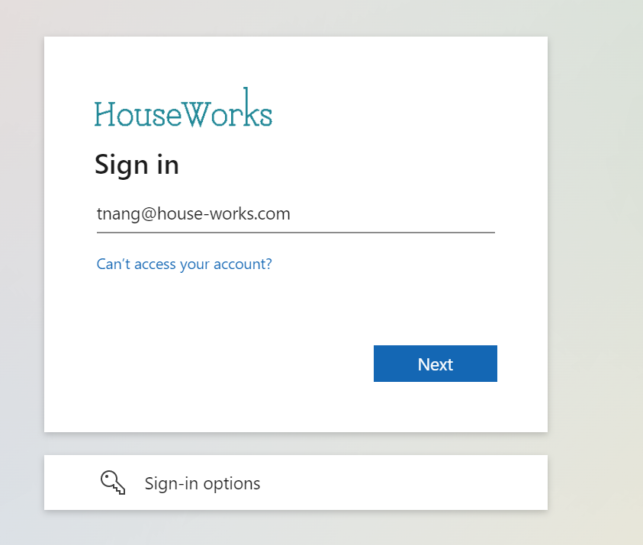
- Enter your network password
  - Please reach out to me if you are unable to sign in or need to have your password reset
  - 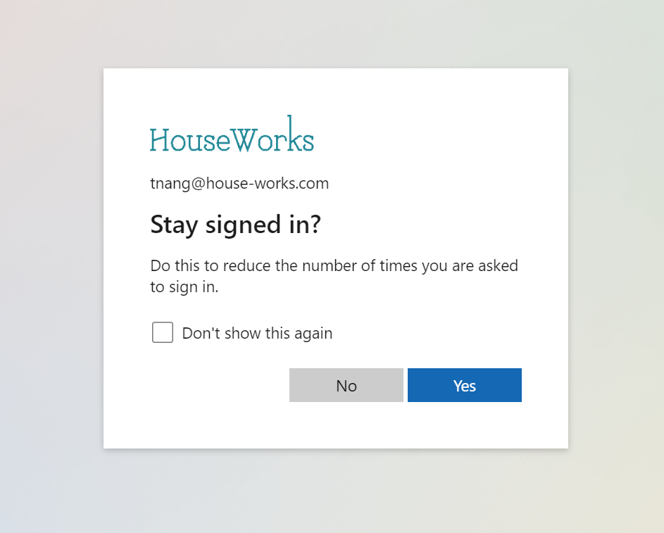
- Check off “Don’t show this again” and click Yes
- If you have done this registration successfully, you should see two items on the next screen.
  - Your phone number to get text verification from Microsoft
  - Microsoft Authenticator for VPN
    - 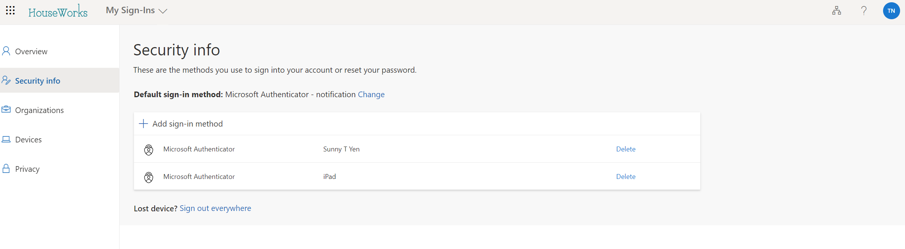
  - If you DO NOT have both, please click on “Add sign in Method”
    - 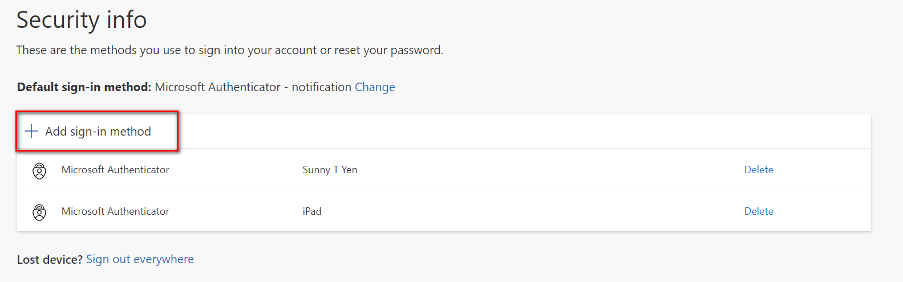
  - Go through the steps of adding your phone number and/or Microsoft Authenticator
    - If you add a phone number, you will get a text from Microsoft to complete the setup
    - If you add Microsoft Authenticator, you will need to scan the QR
      - Please download the Microsoft Authenticator first before scanning QR code
  - Default sign-in method should be the: Microsoft Authenticator
  - Test VPN connection

