Care & Help, LLC. Home Care Agency
1051 County Line Rd.
Huntingdon Valley, PA 19006
Tel: (267) 778-9180 ~ Fax: (215) 689-4274
__________________________________________________
Infection Control
Bloodborne Pathogens & Standard Precautions

Learning Guide

Why is it important to protect yourself from contact with blood and body fluids?

Though they can't be seen, there are hundreds oftiny organisms living in blood and other body fluids that can cause disease in humans. These are called "bloodborne pathogens."

Some of these organisms are harmless and can be handled easily by the body's immune system, but others can cause severe illness, such as hepatitis or AIDS.

Bloodborne Diseases: HIV, Hepatitis B, Hepatitis C

Bloodborne pathogens include the hepatitis B virus (HBV), the hepatitis C virus, the human immunodeficiency virus (HIV) that causes autoimmune deficiency syndrome (AIDS), and others.

These pathogens are transmitted through contact with infected body fluids such as blood, semen, and vaginal secretions. Exposures occur (a) if the skin is punctured by a contaminated needle, razor, or other sharp item, or (b) when broken skin or mucous membranes are splashed with blood or body fluid. Fortunately, most exposures do not result in infections.

Standard precautions are designed to prevent transmission of HIV, HBV, and HCV. Standard precautions must be observed in all situations where there is potential for contact with blood or other potentially infectious body fluids.

Standard precautions apply to:
- Blood
- Semen
- Vaginal secretions
- Saliva
- Cerebrospinal fluid
- Synovial fluid
- Pleural fluid
- Peritoneal fluid

- Pericardia! fluid
- Amniotic fluid
- Feces
- Nasal secretions
- Sputum
- Sweat
- Tears
- Urine
- Vomitus

Treat all human blood and body fluids as if they are infectious.

Standard Precautions for Handling Objects
I. Clean any equipment that has been used by
one client before giving it to another client. Follow your facility's cleaning procedures.
- Use disposable equipment only once.
- Dirty linens should be rolled, not shaken, and
should be held away from your body. Linens soiled with body fluids can be washed with other laundry, using your facility's procedures.
- No special precautions are needed for dishes
or silverware. Normal dish soap and hot water (water temperature must be hot enough to
meet state requirements) will kill germs.
- Change cleaning rags and sponges frequently.
- Stethoscopes, blood pressure cuffs, and thermometers should be cleaned between each use, using your facility's procedures.
- Dispose of dangerous waste such as needles VERY CAREFULLY. Needles and other sharp devices should go into clearly marked puncture-proof containers, NOT the regular trash container! DO NOT RECAP used needles-put them in the puncture-proof container without the cap on.
- Trash that is contaminated with germs, such as
wound dressings, should be disposed of according to your facility's procedures.
- Any container marked "Biohazard" is only for discarding contaminated waste--don't remove anything from it! If you must handle anything in the container, always use gloves. Don't put your hand in anything that contains needles or other sharp objects.
I 0. Check your gloves and other protective
clothing frequently. If you see tears or holes, remove the gloves, wash your hands, and apply clean gloves.

TIP: Don't touch your face (nose, mouth, eyes) when giving client care, unless you remove your gloves and wash your bands first. Protect yourself from infection.

Additional Precautions
If you know that a client has a disease that is spread in one of the following ways, use these extra precautions:

1. Airborne
- The client should have a private room, possibly one with a special air filter.
- Keep the client's room door closed.
- Wear a mask. If the client has, or might have, tuberculosis, wear a special respiratory mask (ask your supervisor). A regular mask wi II not protect you.
- Remind the client to cover nose and mouth when coughing or sneezing.
- Ask the client to wear a mask if he or she wants or needs to be around others.

Contact
- The client should be in a private room, but the door may stay open.
- Put gloves on before entering the room.
- Change gloves after touching a contaminated object (bed linens, clothes, wound dressings).
- Remove gloves right before leaving the room. Don't touch anything else until you wash your hands. Wash your hands ASAP!
- Wear a gown in the room if the client has drainage, diarrhea, or is incontinent. Remove the gown right before leaving the room.
- Use a disinfectant to clean stethoscopes, blood pressure cuffs, or any other equipment used on the infected client.

Droplet
- The client should be in a private room, but the door may stay open.
- Wear a mask when working close to the client (within three feet).
- Ask the client to wear a mask if he or she wants or needs to be around others.

Handwashing Rule: Rub hands together with soap and running water for at least 10 seconds. Germicidal gels are not enough!

USE ADDITIONAL PRECAUTIONS IN ADDITION TO STANDARD PRECAUTIONS WHEN A CLIENT HAS AN ILLNESS REQUIRING EXTRA INFECTION CONTROL MEASURES.

Remember who you are protecting-YOURSELF!

Standard Precaution #1: Handwashing

Handwashing is the single most important thing you can do to prevent the spread of infection. Thorough handwashing removes pathogens from the skin.
Wash hands before and after all client or body fluid contact. Immediately wash hands and other skin surfaces that are contaminated with blood or body fluids. When wearing gloves, wash hands as soon as the gloves are removed.
Germicidal handrubs are recommended only when you can't wash.

Proper Handwashing Procedure

  - Remove watch or push it up your arm. You should not wear rings or bracelets at work.
  - Do not touch the sink with your hands while you are washing, and stand back from the sink to keep it from touching your clothes.
  - Use warm water. Hot water may dry skin.
  - Either bar soap or liquid soap is OK. If using a bar. rinse it first and hold it the whole time you are lathering. Soap does not have to be an antiseptic type, unless you are doing an invasive procedure such as catheterization.
  - Wet your wrists and hands.
  - Apply plenty of soap. Work up a thick lather all over your hands and wrists, between your fingers and thumbs, and on the back of your hands and wrists.
  - Vigorously rub all areas of your hands, fingers, and wrists for a minimum of
10-15 seconds. Sixty seconds is better.
  - Clean under your nails by using the nails on your other hand, or rub your nails into the palm of your other hand. Clean around the top of your nails.
  - Rinse with warm water, letting water run down from wrists to fingertips and into the sink.
  - Dry with a clean paper towel and throw it away. 11.Turn off the faucet with a clean, dry paper towel
and throw the towel away.
- Use lotion on your hands to prevent irritation and chapping, which makes skin more prone to infection.

Standard Precaution #2: Gloves

  - Use gloves in all situations where you may come in contact with blood or body fluids.
  - Use gloves for client care involving contact with mucous membranes, such as brushing teeth.
  - Change gloves and wash hands between client contacts.
  - Use gloves when you have scrapes, scratches, or chapped skin.

  - Do not wash or disinfect disposable gloves for reuse.

Standard Precaution #3: Protective Barriers

Protective barriers, including gloves, reduce the risk of your skin or mucous membranes being exposed to potentially infective blood and body fluids. You should wear the appropriate barriers for the work you are doing.

Employers must provide suitable personal protective equipment (PPE) in the right sizes. Protective equipment
includes gloves, gowns, masks, eye protection, face shields, I
mouthpieces, resuscitation devices, and other things. \...
Hypoallergenic gloves, glove liners, powderless gloves, or other alternatives must be available for those who are allergic to the regular gloves.

The equipment you need depends on your work. When splashing of blood or body fluids is likely, wear the following PPE in addition to gloves:

    - Mask if your face could be splashed with blood or body fluids.
    - Eye protection if your eyes could be splashed with blood or body fluids.
    - Gown if your clothing or skin could be splashed.

Standard Precaution #4: Proper Disposal of Sharp Items

A "sharp" is any object that can penetrate the skin, such as needles, scalpels, broken glass, broken capillary tubes, and exposed ends of wires. A sharp is contaminated if it has been in
_ contact with blood, body fluids, or body tissues.

Contaminated sharps must be disposed of properly. Follow your organization's policies. A puncture-proof biohazardous container must be used in care facilities. Biohazardous waste from facilities (not from client's homes) must be disposed of by specially­ licensed companies.
  - Be careful to prevent injuries from needlesticks and other
sharp instruments after procedures, when cleaning used instruments, and when disposing of used needles. Do not recap or manipulate needles.
  - Nursing and personal care facilities should be using, or planning to use, needleless injection systems or needles with injury protection. If you must use a regular needle, remember:
o Do not recap needles. If it is absolutely necessary to recap a needle, use one hand to slide the needle into a cap lying on a flat surface. Do not hold the cap in your other hand while recapping.

Tips:

--Use thick rubber household gloves to protect your hands during housekeeping chores or instrument cleaning involving potential blood contact.
--Treat all linen soiled with blood or body secretions as potentially infectious.

--Surfaces that have been contaminated with blood or body fluids should be cleaned with a disinfectant according to your organization's policies. Centers for Disease Control

Two-Tiered System To Control
Disease Transmission

Everyone

is a Possible Source

of Bloodborne Infection

Protect Yourself!

TIER 1: Standard Precautions

Basic Precautions to be Used at All Times, with All Clients, to Prevent Transmission of Bloodbome Diseases:

  - Frequent, thorough handwashing.

  - Wear gloves when you might touch blood or body fluids.
  - When splashing of blood or body fluids is likely, wear the following, depending on the situation:
    - Masks

    - Eye protection

    - Gowns

  - Safe use and disposal of sharp items.

IF AN EXPOSURE OCCURS

Immediately following an exposure to blood or body fluids:
  - Wash needlesticks and cuts with soap and water.
  - Flush splashes to the nose, mouth, or skin with water.
  - Irrigate eyes with clean water, saline, or sterile irrigants.

Next,
  - Report the exposure at once. Treatment may be recommended and it should be started as soon as possible. See a medical professional.
  - Discuss the possible risks and the need for treatment with the person managing your exposure.
  - Remember that mandatory testing of a client is not legal. Clients who might be the source of an infection must give consent to be tested.

Workers' Rights

The Occupational Safety and Health Administration (OSHA) is a federal agency that guarantees rights to a safe workplace. Under OSHA's rules, workers who might be exposed to contaminated blood or body fluids have specific rights.

Employers must train workers that might be exposed to blood or body fluids about the hazards and how to protect themselves. This training must occur during working hours at no cost to employees, at orientation and annually thereafter.
Standard precautions must be practiced at all times. Puncture-proof and leak-proof containers must be provided for disposal of sharp items. There must be a system for reporting exposures to blood or body fluids.

Employers must provide free hepatitis B vaccine, free protective equipment, and free immediate medical evaluation and follow-up for anyone exposed to blood or body fluids. Employees must receive confidential treatment, and their medical records must be protected.

Workers' Responsibilities

  - Always use standard precautions.
  - Actively participate in evaluating safer equipment and encouraging your organization to purchase safer equipment. Be open to new products or practices that could prevent exposure and protect workers and clients.
  - Be immunized against hepatitis B, getting the series of three injections.
  - Report all exposures immediately after cleaning and disinfecting the exposed skin or mucus membranes.
  - Comply with post-exposure recommendations of your organization.
  - Support other workers who have been exposed. HIV-infected workers who continue working deserve support and confidentiality.

  - Know your own HIV I HBV I HCV status. If you are positive for any of these viruses. you do not pose a risk for clients if you don't do invasive procedures.

Human Immunodeficiency Virus (HIV) is the virus that causes AIDS

Risk of infection after exposure

- Needlestick is the most common cause of work-related infection.
- Risk factors include the amount of blood or fluid, the puncture depth, and the disease stage of the infected person.
- The average risk of HIV infection after a needlestick or cut exposure is 1 in 300. The risk after exposure of the eye, nose, skin or mouth to positive blood is less than 1 in 1000. If the skin is damaged, the risk may be higher.

Treatment after exposure

- There is no vaccine against HIV.
- Post-exposure treatment is not always recommended. A physician or exposure expert should advise you.
- Drugs used to prevent infection may have serious side effects.
- Perform HIV-antibody testing for at least 6 months after exposure.

99.7% of needlesticklcut exposures do not result in HIV infection.

••••••• 0 •••••• 0. 0 •••••••••• 0. 0 •• 0 •• 0. 0. 0 •••• 0 ••

Hepatitis B Virus (HBV)

Risk of infection after exposure

  - Hepatitis B vaccine prevents this disease. Persons who have received the vaccine and developed immunity are at virtually no risk for infection. A series of three (3) injections are required, given initially, then 1-2 months later, then 4-6 months after the first injection.
  - Workers should be tested 1-2 months after the vaccination series to make sure the vaccination has provided immunity.
  - For the unvaccinated person the risk from a single needlestick or cut exposure ranges from 6-30%, depending on the level of virus in the infected person's blood. A higher concentration of virus makes it more likely that someone exposed to that blood will become infected.

Treatment after exposure

  - Everyone with a chance of exposure to blood or body fluids should receive hepatitis B vaccine, preferably during training, unless it is contraindicated because of allergies, pregnancy, or potential pregnancy.
  - Hepatitis B immune globulin (HBIG) effectively prevents HBV infection after exposure. Recommendations for post-exposure management of HBV may include HBIG and/or hepatitis B vaccine. The decision to begin treatment is based on several factors, such as:
    - Whether the source person is positive for hepatitis B.

    - Whether the worker has been vaccinated. o Whether the vaccine provided immunity.

Hepatitis C Virus (HCV)

Infection with HCV carries a great potential for chronic liver disease and can lead to liver failure, liver transplants and liver cancer.

Risk of infection after exposure
  - Hepatitis C Virus (HCV) is a growing problem.
  - The risk for infection after a needlestick or cut exposure to HCV-infected blood is 1.8%.
  - The risk after a blood splash is unknown, but is believed to be very small; however, HCV infection for such an exposure has been reported.

Treatment after exposure
- There is no vaccine against hepatitis C and no treatment after an exposure that will prevent infection.
- Immune globulin (HBIG) is not recommended.
- Following recommended infection control practices is vital.
- There are several tests that should be performed in the weeks after an exposure and for 4-6 months afterward. Confer with a physician or an exposure specialist.

Additional Precautions for Infection Control
If you know or suspect that a client has a disease that is spread in one of the following ways, use these extra precautions, in addition to standard precautions:

Airborne germs can travel long distances through the air and are breathed in by people. Examples of diseases caused by airborne germs: TB, chickenpox, shingles.

- Wear a mask. If the client has, or might have, tuberculosis, wear a special respiratory mask (ask your supervisor). A regular mask will not protect you.
- Remind the client to cover nose and mouth when coughing or sneezing.
- Treat the client's used tissues or handkerchiefs as infected material.

Contact germs can cause the spread of disease by touch. Examples of diseases caused by contact germs: pink-eye, scabies, wound infections, MRSA.

- Wear gloves.
- Treat bed linens, clothes, and wound dressings as infected material.
- Wear a gown if the client has drainage, diarrhea, or is incontinent.
- Use a disinfectant to clean stethoscopes, blood pressure cuffs, or other equipment.

Droplet germs can travel short distances through the air, usually not more than three feet. Sneezing, coughing, and talking can spread these germs. Examples of diseases caused by droplet germs: flu, pneumonia.

- Wear a mask when working close to the client (within three feet).

MEDICATION OF THE MONTH
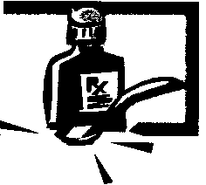
• _,.,
••
Hepatitis B Immune Globulin (HBIG)

Hepatitis B immune globulin is used to prevent hepatitis B. It is effective when given to someone after they have been exposed to hepatitis B. It may be given to workers who are exposed to the virus by means of blood, blood products, or human bites. Babies born to mothers who test positive for hepatitis B, and sexual partners of persons with hepatitis B may also receive Hepatitis B immune globulin. People who have been vaccinated and/or are immune to Hepatitis B usually do not need HBIG.

How supplied: For injection.
Dosage is based on weight and will be determined by the physician. Before using hepatitis B immune globulin (human) consider the following:

  - Allergies-allergic to foods, preservatives, or dyes.

  - Pregnancy-Studies on effects in pregnancy have not been done.

  - Breastfeeding-lt is not known if this immune globulin passes into breast milk.

  - Children-This medicine is not expected to cause different side effects or problems in children than in adults.

  - Older adults-There is no information comparing use of hepatitis B immune globulin in the elderly with use in other age groups.

  - Other medications-When you are taking hepatitis B immune globulin let your physician know if you are taking any other vaccines such as vaccines made from a live virus (except oral poliovirus vaccine or yellow fever vaccine). Hepatitis B immune globulin may interfere with results of other vaccines.

  - Medical problems-Make sure your physician is aware of:

    - Bleeding problems-injection may cause bleeding.

o Immune system problems-this medication may cause severe allergic reactions.

  - Side effects are discomfort, headache, muscle aches or pain, nausea, pain at the injection site.

  - Less common side effects include abdominal or stomach cramping; burning, heat, and redness at the injection site; chills; diarrhea; feeling as though you are going to vomit; lightheadedness; unusual tiredness or weakness.

RESPIRATORY HYGEINE

......,.......

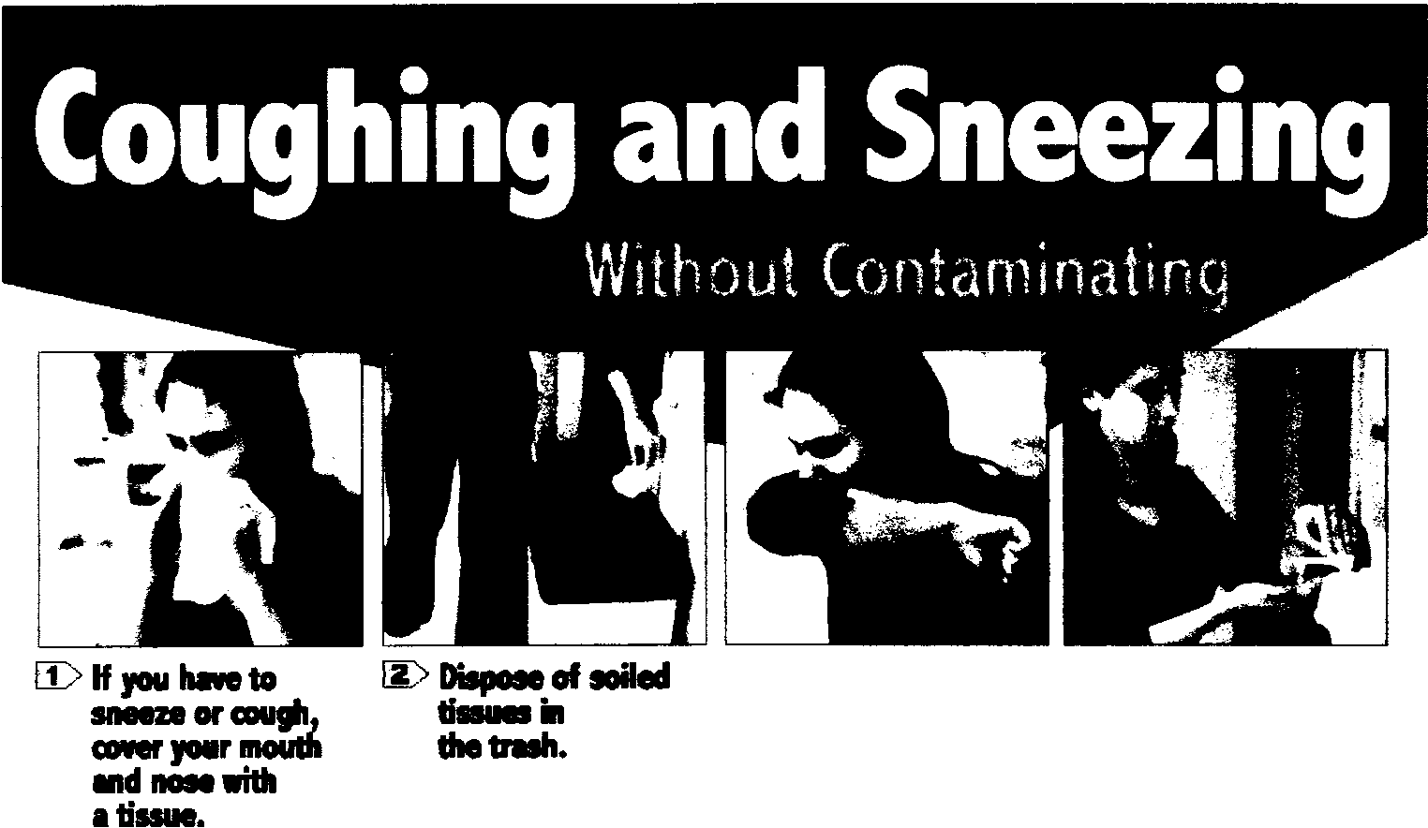

HAND HYGEINE

Wash Your Hands!
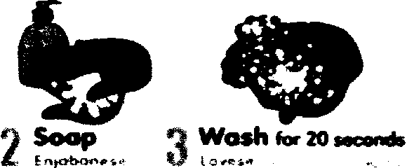
ilOvese Las Manos!

